Hybrid Recommender System

Bansil Patel   
Artificial Intelligence and Machine Learning  
Lambton CollegeToronto, Canada  
[c0902873@mylambton.ca](mailto:c0902873@mylambton.ca)  
  
Harsh Mohile  
Artificial Intelligence and Machine Learning  
Lambton CollegeToronto, Canada  
[c0912872@mylambton.ca](mailto:c0912872@mylambton.ca)  
  
Meet Patel  
Artificial Intelligence and Machine Learning  
Lambton CollegeToronto, Canada  
[c0910378@mylambton.ca](mailto:c0910378@mylambton.ca)  
  
Rachit Bhatt  
Artificial Intelligence and Machine Learning  
Lambton CollegeToronto, Canada  
[c0902810@mylambton.ca](mailto:c0902810@mylambton.ca)

*Abstract*—This article describes a system that recommends using collaborative and content-based filtering for users predicting a movie. With the help of Matrix Factorization and neural networks, achieved hybrid recommendation system with EDA. Use of MovieLens dataset and tweets related to movies, comparing both techniques using RMSE, MAE, Precision, Recall, and F1-Score. The hybrid system implies a neural embedding layer in PyTorch, resulting in effective integration of content-based and collaborative filtering with sentiments, and highlighting improvements in accuracy as well as user satisfaction.

Keywords—rotten tomatoes, comments, analysis, sentiment analysis, social media analysis, web scraping, user engagement, data visualization.

# Introduction

The recommended systems are vital in modern data-driven applications, enabling personalized user experiences by suggesting items of interest. Traditional systems include content-based filtering, collaborative filtering, and hybrid methods [3]. The collaborative filtering estimates the user preferences based on their historical interactions, while the hybrid model integrates both approaches and enhances user experience [4]. With the help of Matrix Factorization in Collaborative Filtering and NN layers in PyTorch, the prediction of content for the user based on their preferences becomes realistic and the significance of their comparison expands the understanding the impact of incorporating diverse data sources from Rotton Tomatoes [5].

# Related Study

Recommender systems have been extensively studied across various domains, and different techniques have been proposed to enhance their performance. He et al. [1] introduced neural collaborative filtering, demonstrating its efficiency in capturing user-item interactions with neural networks. Koren et al. [2] presented a foundational technique for collaborative filtering, leveraging latent factor models for accurate recommendations. Item-to-item collaborative filtering used by Amazon, as presented by Linden et al. [3], excels in scalability and precision.

Comparative studies such as Said and Mauro’s [4] underscore the strengths and weaknesses of different collaborative filtering algorithms. Ricci et al. [5] provided a comprehensive overview of recommender systems, emphasizing hybrid approaches. The implementation of matrix factorization that sets a benchmark for the recommendation accuracy as documented by Funk [6] behind Netflix’s success. Sarwar et al. [7] introduced item-based algorithms, proving their robustness in sparse datasets.

The trust-aware systems integrate social trust into recommendations and enhancing user satisfaction as explored by Jamali and Ester [8]. The survey of Burke [9] on hybrid systems demonstrated their versatility in combining collaborative and content-based methods. Aggarwal [10] emphasized content-based recommenders’ adaptability in niche domains, paving the way for advanced hybrid models. These studies collectively establish a foundation for this project’s exploration of collaborative filtering, content-based filtering, and a hybrid model.

# Methodology

This component outlines the methodologies for building collaborative filtering and hybrid recommender systems. We use the Matrix Factorization algorithm for collaborative filtering and PyTorch’s embedding layer for the hybrid model [2][5].

## System Architecture

Process Flow for Sentiment Score

## Dataset

1. Dataset Description

| Sr. No. | Dataset – u.data | | |
| --- | --- | --- | --- |
| Description | Column | Type |
| 1. | ID of users. | user_id | int |
| 2. | ID of items. | item_id | int |
| 3. | Ratings of a movie. | rating | int |
| 4. | Time of data generated. | timestamp | int |

1. Dataset Description

| Sr. No. | Dataset – u.item | | |
| --- | --- | --- | --- |
| Description | Column | Type |
| 1. | ID of movie. | movie_id | int |
| 1. | ID of movie. | movie_id | int |
| 2. | Title of the movie. | movie_title | str |
| 3. | Movie release date. | release_date | datetime |
| 4. | Release date of the video. | video_release_date | datetime |
| 5. | URL of IMDB reviews. | IMDB_URL | str |
| 6. | Movie Genre – Unknown | unknown | int |
| 7. | Movie Genre – Action | Action | int |
| 8. | Movie Genre – Adventure | Adventure | int |
| 9. | Movie Genre – Animation | Animation | int |
| 10. | Movie Genre – Children | Children | int |
| 11. | Movie Genre – Comedy | Comedy | int |
| 12. | Movie Genre – Crime | Crime | int |
| 13. | Genre – Documentry | Documentary | int |
| 14. | Movie Genre – Drama | Drama | int |
| 15. | Movie Genre – Fantasy | Fantasy | int |
| 16. | Movie Genre – Film-Noir | Film-Noir | int |
| 17. | Movie Genre – Horror | Horror | int |
| 18. | Movie Genre – Musical | Musical | int |
| 19. | Movie Genre – Mystery | Mystery | int |
| 20. | Movie Genre – Romance | Romance | int |
| 21. | Movie Genre – Sci-Fi | Sci-Fi | int |
| 22. | Movie Genre – Thriller | Thriller | int |
| 23. | Movie Genre – War | War | int |
| 24. | Movie Genre – Western | Western | int |

1. Dataset Description

| Sr. No. | Dataset – Scrapped | | |
| --- | --- | --- | --- |
| Description | Column | Type |
| 1. | ID of movies from *u.data*. | movie_id | int |
| 2. | Name of the movie. | movie_title | str |
| 3. | Avg Sentiment of Movie. | sentiment_score | float |

## Matrix Factorization – Collaborative Filtering

Process of taking a matrix and decomposing it into a product of two triangular matrices [11].

**Equation:** 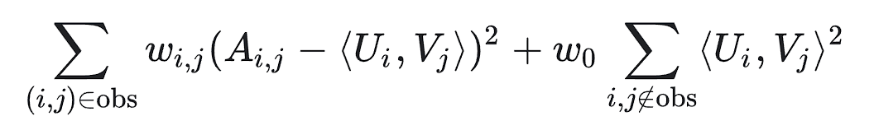

where wi,j is a function of the frequency of query I and item j.

**Example:**

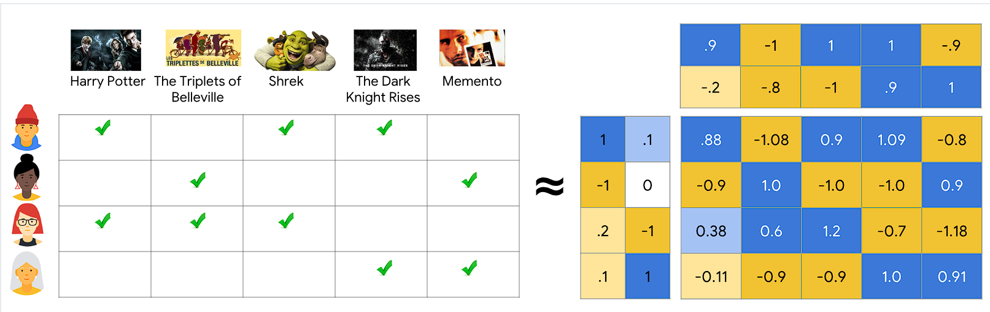

Simple Embedding Model explaining concept

## Neural Embedding Layer

A tool used to convert high-dimensional data into a lower-dimensional space.

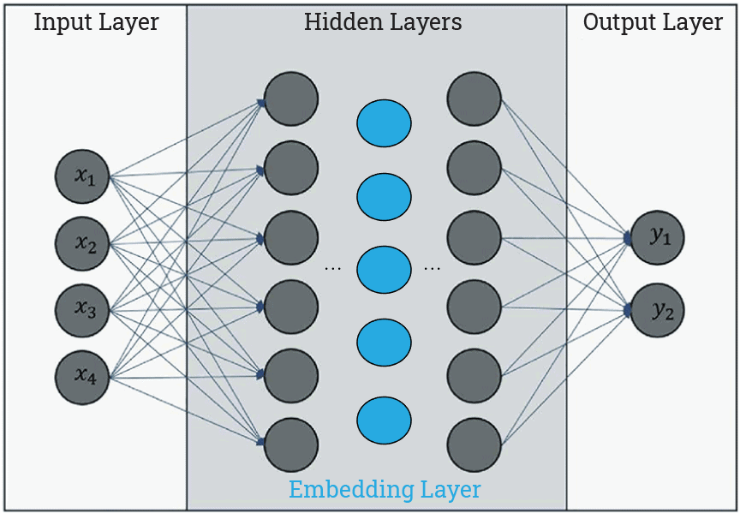

Embedding Layer [13]

The layer converts data into vedctors. A vector is a list of numbers. Each words, assigned a unique vector.

## Sentiment Score

VADER stands for Valence Aware Dictionary and sEntiment Reasoner), a lexicon and rule-based sentiment analysis tool that is specifically attuned to sentiments expressed in social media.

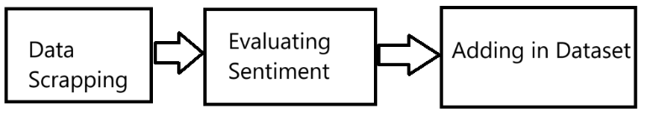

Process Flow for Sentiment Score

While scraping the data from the web, the sentiment score is evaluated based on the comments fetched while scraping [14]. The VADER sentiment analyzer performs the operation, and an average of all sentiments is stored in the dataset for each movie.

## Activation Function

Activation function calculates the weighted sum of inputs and adds a bias.

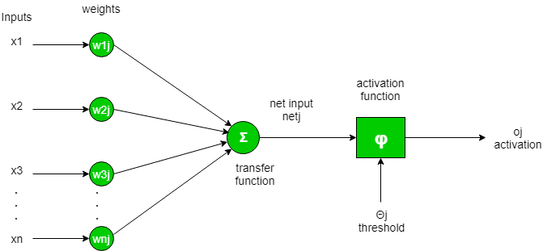

Activation Function [15]

**Formula:** 

# Experiments

## Experiment Design

In our project, we have tried X and Rotten Tomato for scraping data. While X was not allowing access to their data after a few trials, ending up with a few records incompatible for a neural network problem, the Rotton Tomato provided data with many null values randomly.

For the experiment, we have used the Latent Vector Size for Matrix Factorization and Embedding-Based Neural Network [2] for the hybrid model.

## Dataset Preparation

The final dataset for the model training was split using the standard *train_test_split()* function with 80/20 ratio.

## Evaluation Metrics

Metrics helps in identifying how well the model is performing. There are various metrics used in this process:

### RMSE: Root Mean Square Error is average difference between model’s predicted and actual values [2].

### MAE: Mean Absolute Error helps in evaluating regressive model accuracy [5].

### Precision: Number of true positive values either correctly or incorrectly identified by the model.

### Recall: True positive rate measuring the true positives based on true positive and false negative values.

### F1–Score: Derived from harmonic mean of precision and recall [16].

## Results and Analysis

### Hyperparameter Selection

**Early Stopping:** Stops the neural network to run more epochs based on the loss of the data detected while training to save the resources.

**Learning Rate:** Rate of learning to prevent vanishing gradient descent. We have used **0.001** as our learning rate.

**Patience:** Process of letting the epochs run if the early stopping parameter is not satisfactorily increasing/decreasing. We have used **5** as patience.

**Optimizer:** Optimization technique for gradient descent to prevent the vanishing gradient at a certain extent. We have used **Adam** optimizer.

### Results of Recommendation Models

#### Collaborative Filtering

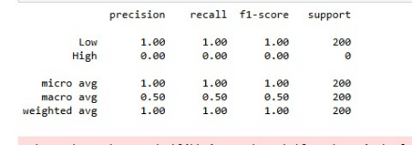

Metrics

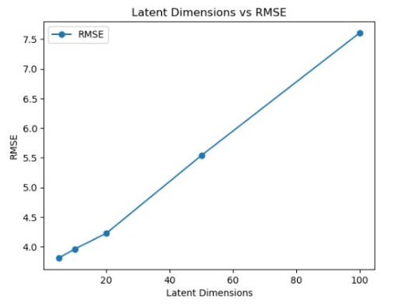

Latent Dimensions vs RMSE

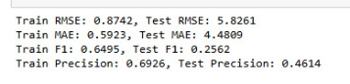

Train-Test Metrics

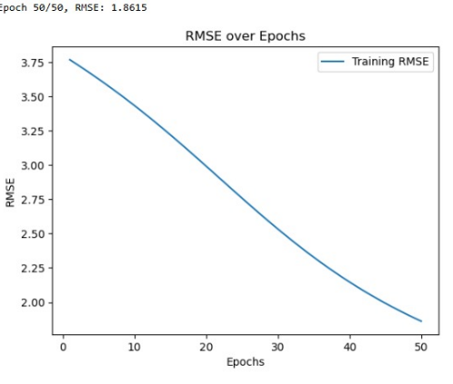

RMSE over Epochs Curve

#### Hybrid Model

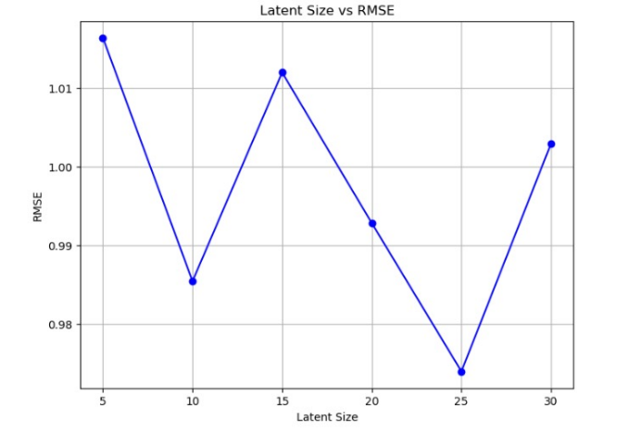

Latent Size vs RMSE

Metrics

#### Model Comparison

Model Comparison

The Collaborative Filtering RMSE and MAE scores were significantly large as compared to the Hybrid Recommender. The Hybrid Recommender performs way better than the Collaborative model.

# Conclusion

This project demonstrated the enhanced accuracy of hybrid recommender systems by integrating collaborative filtering with content-based features and sentiment analysis. The hybrid model outperformed traditional collaborative filtering across all evaluation metrics, validating the effectiveness of combining multiple data sources [1][2][5].

##### References

1. X. He, L. Liao, H. Zhang, L. Nie, X. Hu, and T.S. Chua, “Neural collaborative filtering”, in *Proceedings of the 26th international conference on the world wide web*, 2017, pp. 173-182.
2. Y. Koren, R. Bell, and C. Volinsky, “Matrix factorization techniques for recommender systems”, *Computer*, vol. 42, no. 8, pp. 30-37, 2009.
3. G. Linden, B. Smith, and J. York, “Amazon.com recommendations: Item-to-item collaborative filtering”, *IEEE Internet Computing*, vol. 7, no. 1, pp. 76-80, 2003.
4. A. Said and V. N. Mauro, “A comparative analysis of collaborative filtering algorithms”, in *Proceedings of the 13th ACM conference on recommender systems*, 2019, pp. 215-223.
5. F. Ricci, L. Rokach, and B. Shapira, “Introduction to recommender systems handbook”, in *Recommender Systems Handbook*. Boston, MA: Springer, 2011, pp. 1-35.
6. S. Funk, “Netflix update: Try this at home”, *S. Funk’s Blog*, 2006. <https://sifter.org/~simon/journal/20061211.html>.
7. B. M. Sarwar, G. Karypis, J. A. Konstan, and J. Riedl, “Item-based collaborative filtering recommendation algorithms”, in *Proceedings of the 10th international conference on World Wide Web*, 2001, pp. 285-295.
8. M. Jamali and M. Ester, “Trust-aware recommender system”, in *Proceedings of the 15th ACM SIGKDD international conference on Knowledge discovery and data mining*, 2009, pp. 983-992.
9. R. Burke, “Hybrid recommender systems: Syrvey and experiments”, *User Modeling and User-Apadated Interaction*, vol 12, no. 4, pp. 331-370, 2002.
10. C. C. Aggarwal, “Content-based recommender systems”, in *Recommender Systems: The Textbook*. Cham: Springer, 2016, pp.139-166.
11. GeeksForGeeks. *What is Embedding*. Online. <https://www.geeksforgeeks.org/what-is-embedding-layer/>
12. CalcWorkshop. *Matrix Factorization – Step-by-Step for* Students. Online. <https://calcworkshop.com/matrix-algebra/matrix-factorization/>
13. baeldung. *What Are Embedding Layers in Neural Networks?*. Online. <https://www.baeldung.com/wp-content/uploads/sites/4/2023/01/embedding_layer.png>
14. VaderSentiment. *Official Documentation*. Online. <https://vadersentiment.readthedocs.io/en/latest/>
15. GeeksForGeeks. *Activation Functions*. Online. <https://www.geeksforgeeks.org/activation-functions/>
16. GeeksForGeeks. *F1 Score*. Online. <https://www.geeksforgeeks.org/f1-score-in-machine-learning/>